Ex.no:9 | MINI PROJECT – SPORTS DATA ANALYTICS

Aim:

To analyze Sports Data using Tableau by performing data preparation, calculated-field analysis, interactive visualizations, parameters, filters, and dashboards to identify patterns in sports performance, wins and losses, attendance, revenue, fan ratings, teams, leagues, and event trends.

Algorithm:

Load the Sports Analytics dataset from the CSV file using Pandas.

Clean the data by handling missing values, removing duplicate records, and eliminating unnecessary attributes.

Transform the data by standardizing columns and deriving useful fields such as win percentage and performance group.

Store the cleaned and transformed dataset in a PostgreSQL database named sports_analytics.

Connect the PostgreSQL database to Tableau for data analysis and reporting.

Create calculated fields in Tableau for key metrics such as total events, total matches, total wins, total losses, win rate, revenue, and average performance.

Develop interactive visualizations to analyze sports performance, teams, leagues, attendance, revenue, fan ratings, and event trends.

Apply Tableau parameters, filters, dashboard actions, and interactive features for deeper analysis.

Generate important sports insights from the Tableau dashboard and Story.

End the process.

Architecture:
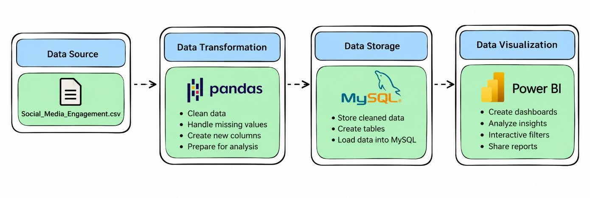

Program:

1. Python – Data Cleaning & Transformation

import pandas as pd

from sqlalchemy import create_engine, text

# Load dataset

df = pd.read_csv("Sports_Analytics_Dataset.csv")

# Create a copy for processing

sports = df.copy()

# Handle missing values

sports["month"] = sports["month"].fillna("Unknown")

sports["sport"] = sports["sport"].fillna("Unknown")

sports["league"] = sports["league"].fillna("Unknown")

sports["team"] = sports["team"].fillna("Unknown")

sports["venue"] = sports["venue"].fillna("Unknown")

# Remove duplicate records

sports.drop_duplicates(inplace=True)

# Convert event date

sports["event_date"] = pd.to_datetime(
sports["event_date"]
)

# Create derived columns

sports["win_rate_calculated"] = (
sports["wins"] / sports["matches_played"]
)

# Avoid division problems

sports["win_rate_calculated"] = (
sports["win_rate_calculated"].fillna(0)
)

# Create performance group

sports["performance_group"] = pd.cut(
sports["performance_score"],
bins=[-1, 60, 80, float("inf")],
labels=["Low", "Medium", "High"]
)

# Standardize column names

sports.columns = (
sports.columns
.str.lower()
.str.strip()
.str.replace(" ", "_")
)

print("Original Shape:", df.shape)

print("Cleaned Shape:", sports.shape)

sports.head()

2. PostgreSQL – Database and Data Loading

PostgreSQL

CREATE DATABASE IF NOT EXISTS sports_analytics;

Python/Jupyter

username = "postgres"

password = "YOUR_POSTGRES_PASSWORD"

host = "localhost"

port = 5432

# Connect to PostgreSQL database

db_engine = create_engine(
f"postgresql+psycopg2://{username}:{password}@{host}:{port}/sports_analytics"
)

# Load cleaned data into PostgreSQL

sports.to_sql(
"sports_data",
con=db_engine,
if_exists="replace",
index=False,
chunksize=5000
)

print("Data loaded successfully into PostgreSQL.")

Verify

pd.read_sql(
"SELECT COUNT(*) AS total_rows FROM sports_data",
db_engine
)

3. Tableau – Calculated Fields

Total Wins

[Wins]

Name:

Total Wins

Win Rate

IF [Matches Played] > 0 THEN

[Wins] / [Matches Played]

END

Name:

Win Rate

Performance Group

IF [Performance Score] >= 80 THEN

"High"

ELSEIF [Performance Score] >= 60 THEN

"Medium"

ELSE

"Low"

END

Name:

Performance Group

Average Attendance

No calculated field is required.

In Tableau:

AVG([Attendance])

Total Events

COUNTD([Event Id])

Total Revenue

SUM([Revenue])

Average Fan Rating

AVG([Fan Rating])

Average Performance

AVG([Performance Score])

Tableau Dashboard
Created visuals in tableau in separate sheets and created a dashboard

Output:

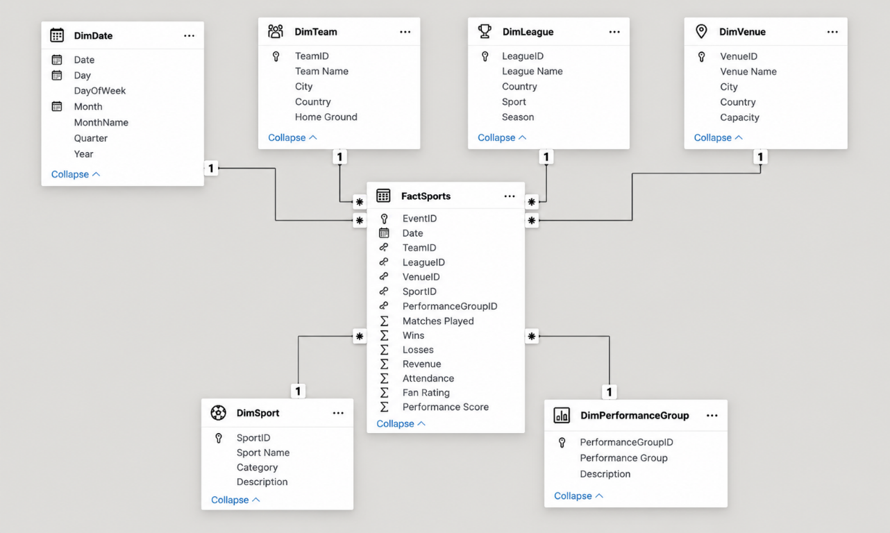

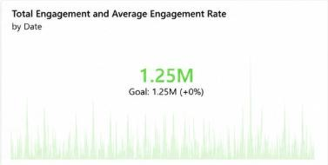

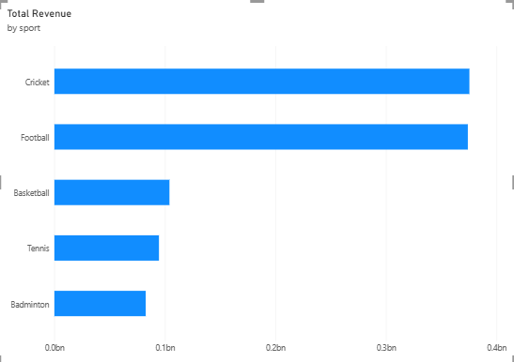

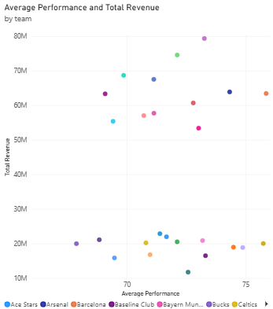

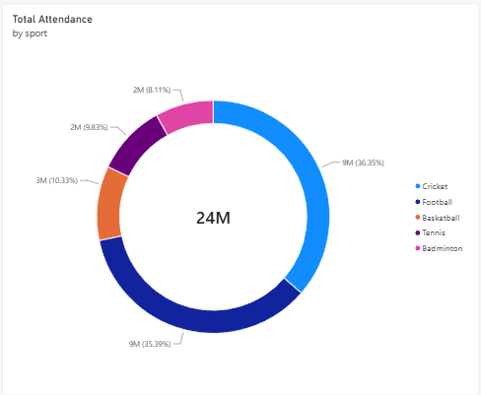

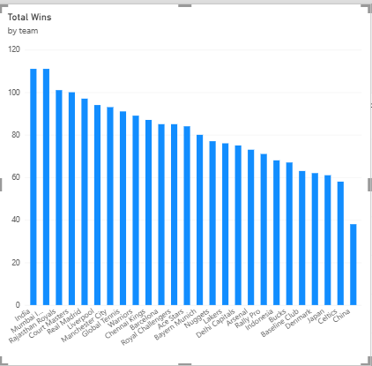

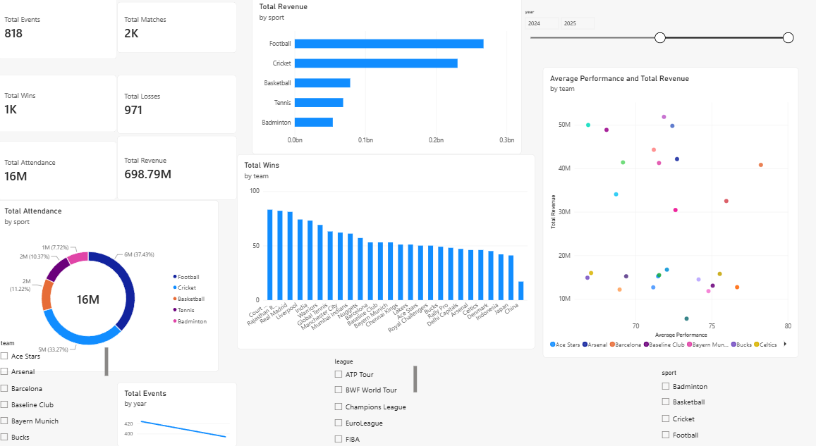

Result:

